ICON GAME 1/00



Intro 2/00



Main menu 3/00

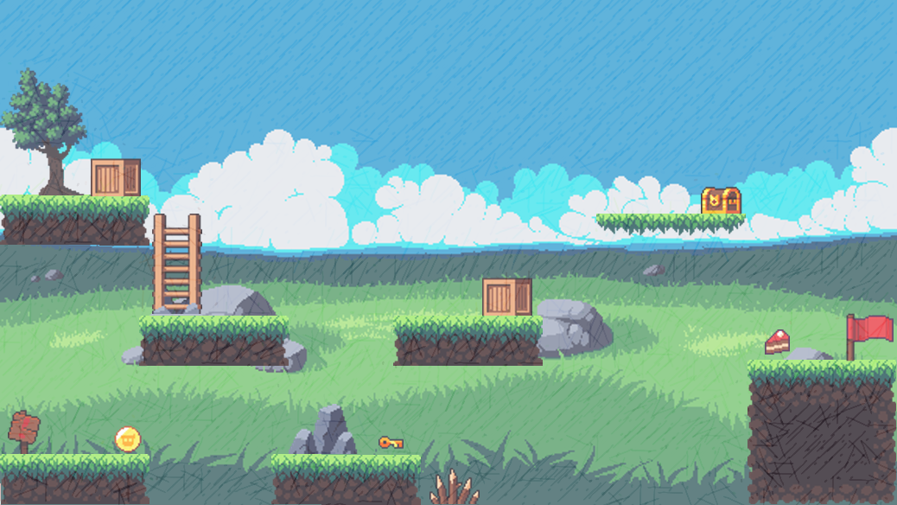

**PIXEL ADVENTURE**



**START**



**SETTING**



**EXIT**

Option menu 4/00

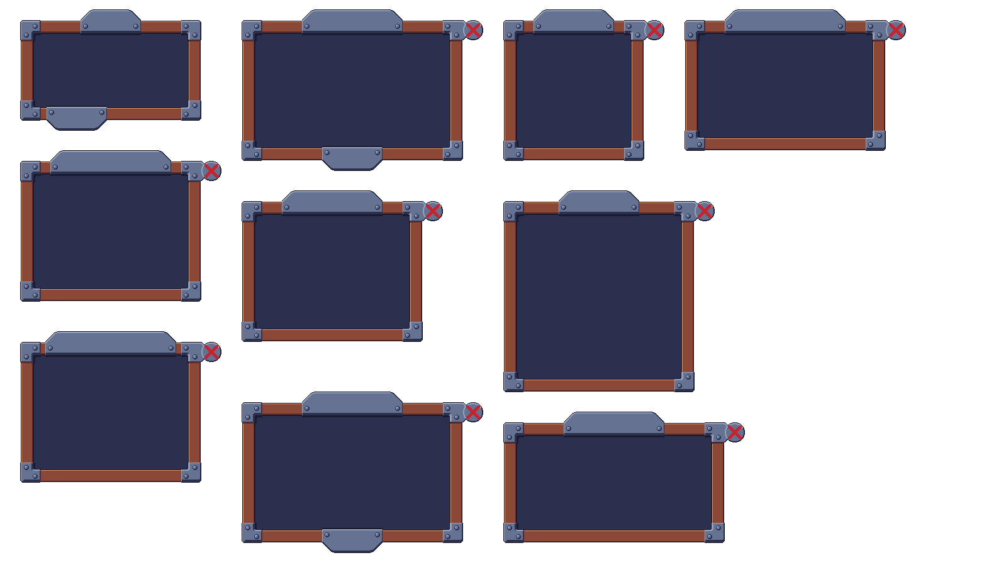

**SETTING**



**MUSIC**



**SOUND**



**1920 * 1080**

**FULLSCREEN**

**WINDOW**

**DISPLAY**

**RESOLUTION**

**BACK**

Controls menu 5/00